**20/09/2021 ML LAB 3 2019103573**

**ILLUSTRATION OF 3 ALGORITHMS USING KNIME TOOL**

**DATASET: IRIS DATASET**

**1. 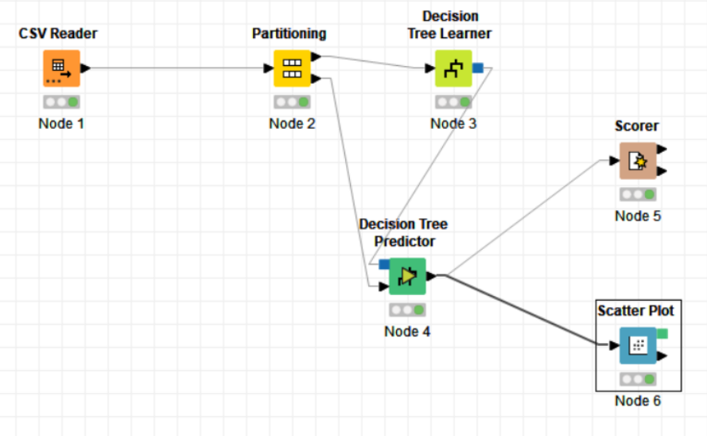CLASSIFICATION (DECISION TABLE) WORKFLOW**

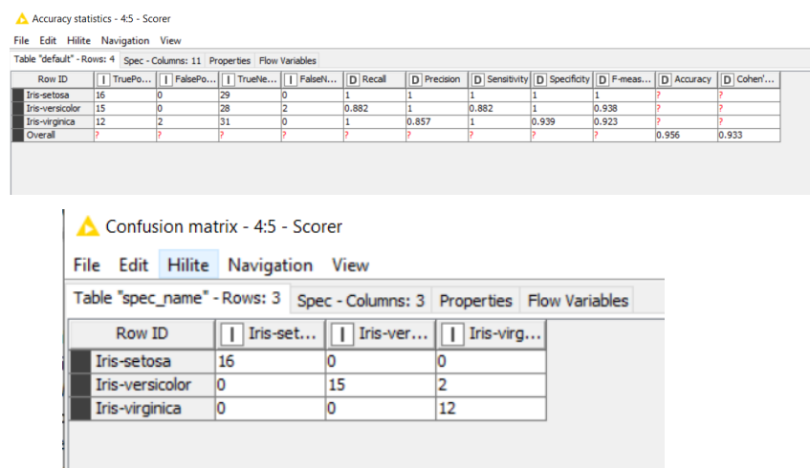

**The Accuracy statistics and Confusion Matrix can be used as performance metrics**

**2. 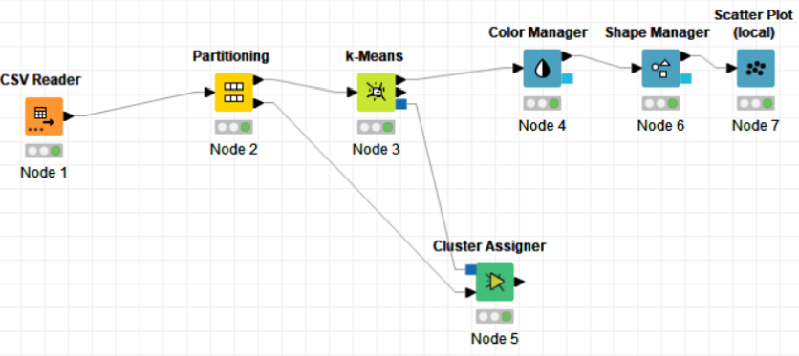CLUSTERING (K MEANS) WORKFLOW**

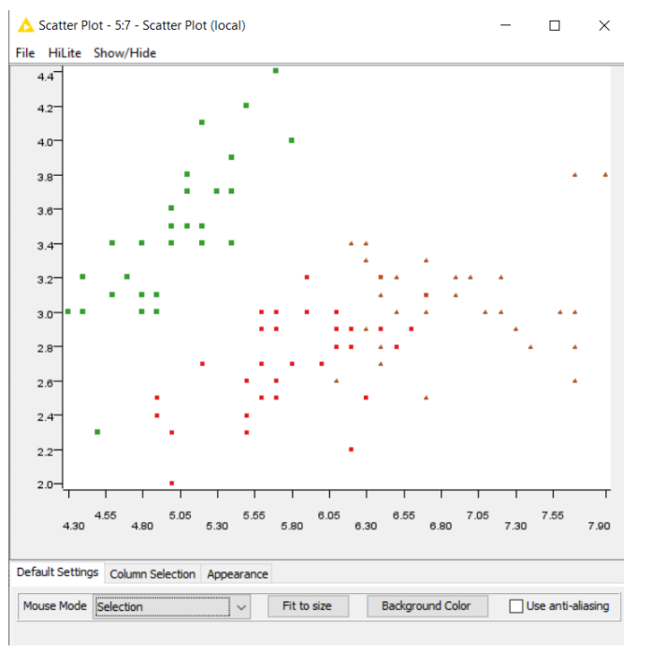

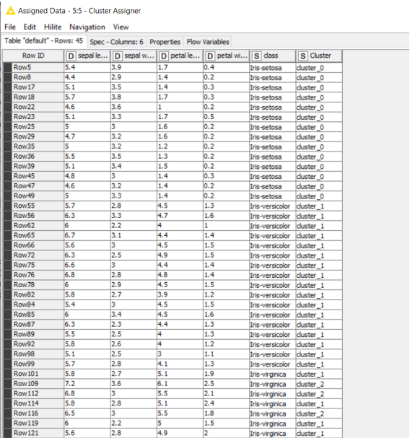

**The scatter plot can be used as a performance metric**

**3. 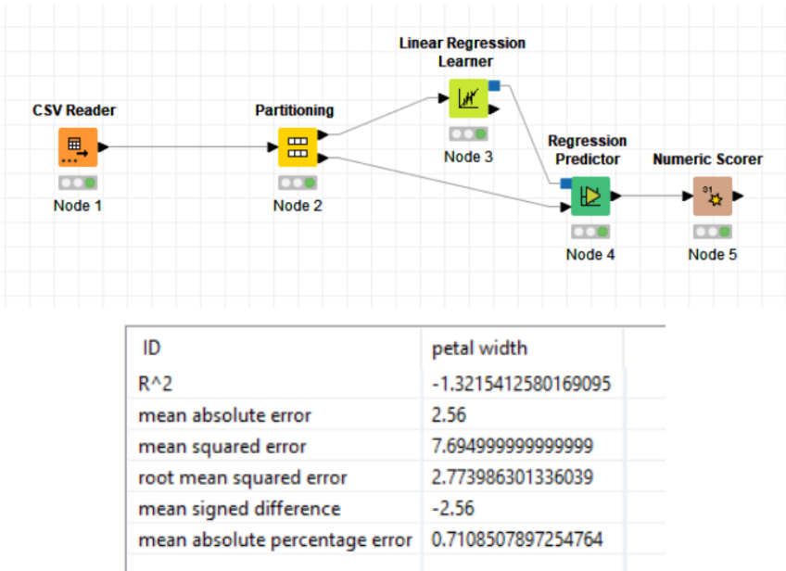REGRESSION (LINEAR REGRESSION) WORKFLOW**

**The different types of errors calculated can be used as a performance metric**

